WEEK 4 – MACHINE LEARNING MODEL DEVELOPMENT & EVALUATION

Submitted By
ANJALI UMESH

Introduction
The objective of this task is to develop a machine learning model to predict customer churn using the IBM Telco Customer Churn dataset. Customer churn refers to customers discontinuing the services provided by a company.
A Random Forest Classifier was implemented using Python and Scikit-learn. The model was trained and evaluated using different performance metrics. An improved model was also developed to reduce overfitting and improve churn detection.

Dataset Description
The IBM Telco Customer Churn dataset contains 7,043 customer records and 21 columns.
The dataset includes customer information such as gender, tenure, contract type, internet service, monthly charges, total charges and churn status.
The target variable was Churn, which was converted into binary values:
- No = 0
- Yes = 1
The customerID column was removed because it is only an identifier and does not contribute meaningful predictive information.

Data Preprocessing
The following preprocessing steps were performed:
- Loaded the cleaned dataset prepared during Week 1.
- Removed the customerID column.
- Separated input features (X) and target variable (y).
- Converted categorical variables into numerical values using Pandas get_dummies().
- Divided the dataset into training and testing sets.
- Used an 80:20 split with stratification to preserve the churn distribution.
Training records: 5,634
Testing records: 1,409
The training data was used to build the model, while the testing data was used to evaluate its performance.

Model Development
A Random Forest Classifier was selected for customer churn prediction.
The original model used the following parameters:
- n_estimators = 100
- random_state = 42
- class_weight = balanced
The model was trained using the training dataset and used to predict customer churn on the testing dataset.

Original Model Evaluation
The original Random Forest model produced the following results:
Evaluation Metric | Result
Accuracy | 79.13%
Precision | 63.89%
Recall | 49.20%
F1-score | 55.59%
AUC | 0.8224
The model achieved an accuracy of 79.13%. However, its recall for customers who churned was only 49.20%, indicating that it missed a considerable number of actual churn cases. The AUC score of 0.8224 indicates good ability to distinguish between customers who stayed and customers who churned.

Confusion Matrix – Original Model
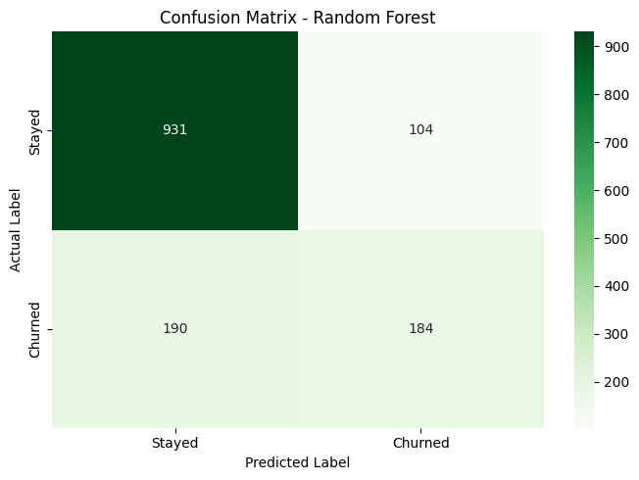
The confusion matrix results were:
Actual / Predicted | Stayed | Churned
Stayed | 931 | 104
Churned | 190 | 184
The model correctly predicted 931 customers who stayed and 184 customers who churned. However, it incorrectly predicted 190 customers who actually churned as customers who would stay. This indicates that the original model needs improvement in identifying churn cases.

ROC Curve – Original Model
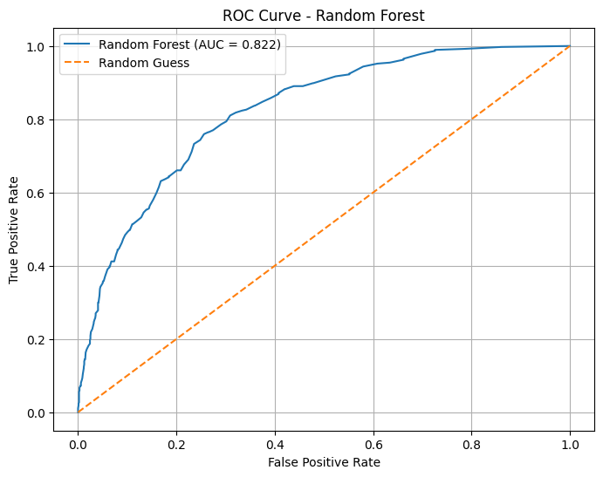
The original model achieved an AUC score of 0.8224. The ROC curve was above the random-guessing diagonal, indicating that the model performed better than random classification.

Overfitting Analysis
Training and testing accuracy were compared to identify overfitting.
Metric | Result
Training Accuracy | 99.80%
Testing Accuracy | 79.13%
Accuracy Difference | 20.67 percentage points
The training accuracy was considerably higher than the testing accuracy. This indicates overfitting, meaning that the model learned the training data too closely and did not generalize equally well to unseen data.

Improved Random Forest Model
To reduce overfitting, an improved Random Forest model was developed using the following parameters:
- n_estimators = 100
- max_depth = 10
- min_samples_split = 10
- min_samples_leaf = 5
- class_weight = balanced
- random_state = 42
Limiting the tree depth and increasing the minimum samples required for splitting and leaf nodes helped reduce model complexity.

Improved Model Results
Evaluation Metric | Result
Accuracy | 76.30%
Precision | 53.69%
Recall | 77.81%
F1-score | 63.54%
AUC | 0.8456
Training Accuracy | 81.75%
Testing Accuracy | 76.30%
The improved model reduced overfitting. Its recall increased from 49.20% to 77.81%, and its F1-score increased from 55.59% to 63.54%.
Although accuracy and precision decreased slightly, the improved model became more effective at identifying customers who were likely to churn.

Confusion Matrix – Improved Model
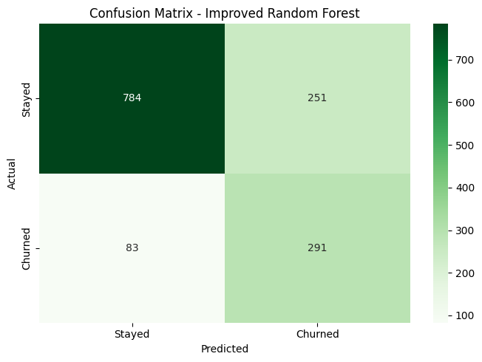
The improved confusion matrix results were:
Actual / Predicted | Staye | Churned
Stayed | 784 | 251
Churned | 83 | 291
The improved model correctly identified 291 customers who churned and reduced false negatives from 190 to 83. This demonstrates improved detection of customers at risk of leaving the company. However, false positives increased to 251, meaning that some customers who stayed were incorrectly predicted to churn.

ROC Curve – Improved Model
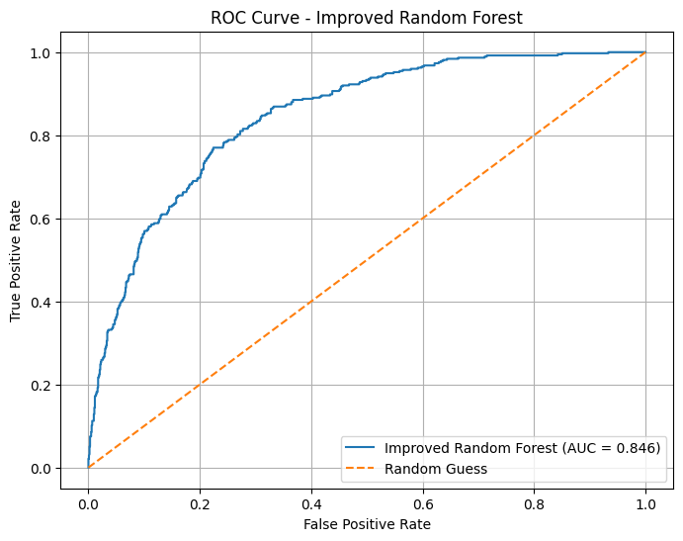
The improved model achieved an AUC score of 0.8456, compared to 0.8224 for the original model. This indicates an improvement in the model's ability to distinguish between customers who stayed and customers who churned.

Model Comparison
Metric | Original Model | Improved Model
Accuracy | 79.13% | 76.30%
Precision | 63.89% | 53.69%
Recall | 49.20% | 77.81%
F1-score | 55.59% | 63.54%
AUC | 0.8224 | 0.8456
Training Accuracy | 99.80% | 81.75%
Testing Accuracy | 79.13% | 76.30%
The improved model achieved better recall, F1-score and AUC, while also reducing the training-testing accuracy gap from 20.67 to 5.45 percentage points.

Challenges and Possible Improvements
The original model showed overfitting and had difficulty identifying a significant number of actual churn cases.
The model was improved by adjusting Random Forest parameters to reduce complexity.
Further improvements could include:
- Hyperparameter tuning using GridSearchCV or RandomizedSearchCV.
- Experimenting with other classification algorithms.
- Applying different class-balancing techniques.
- Adjusting the classification threshold.
- Using cross-validation for more reliable evaluation.

Conclusion
This task demonstrated how machine learning can be used to predict customer churn using Python. A Random Forest Classifier was developed and evaluated using accuracy, precision, recall, F1-score, confusion matrices and ROC-AUC. The original model achieved 79.13% accuracy but showed signs of overfitting. An improved model was developed, reducing overfitting and increasing recall to 77.81% and AUC to 0.8456.
The improved model is more effective at identifying customers likely to churn, although it produces more false positives. These predictions could help businesses identify customers who may need additional attention and develop better customer-retention strategies.

Tools and Technologies Used
- Python
- Google Colab
- Pandas
- NumPy
- Matplotlib
- Seaborn
- Scikit-learn
- Random Forest Classifier

GitHub Repository
GitHub Link: https://github.com/anjaliumesh477/Python-Apprentice-Internship

